Рабочий лист

Фамилия, имя: ____________________________________________________________________

Схема движения группы.

Парадное крыльцо – зона мастер-классов (2 этаж) – вестибюль (Голографическая инсталляция «Современная Россия») – Зона артефактов «До 1722» – «1722–1917» – «После 1917» – конференц-зал.

- Парадное крыльцо (на улице).

№ 1. In the fresco inside the portico you can see the triumphant people of different jobs and nationalities. Look at the fronton of the building and find the name of their country.
_________________________________________________________

№ 2. The decorations in the fresco also include some frets reflecting the _________ and _________ revolution in the country. Choose two variants:
- industrial;
- space;
- agricultural.

№ 3. The building of the pavilion was built in the style of ‘Stalinist Empire’. This style combines the classical and Soviet elements. Look at the three orders of Greek architecture:

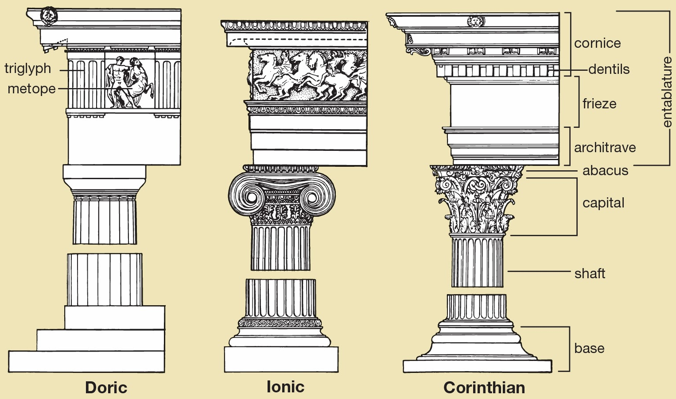

Look for the columns both outside and inside the building. Look at their capitals and identify the orders. ______________________________________________________________________________
- Зона мастер-классов (2 этаж).

№ 4. Fill in the form.

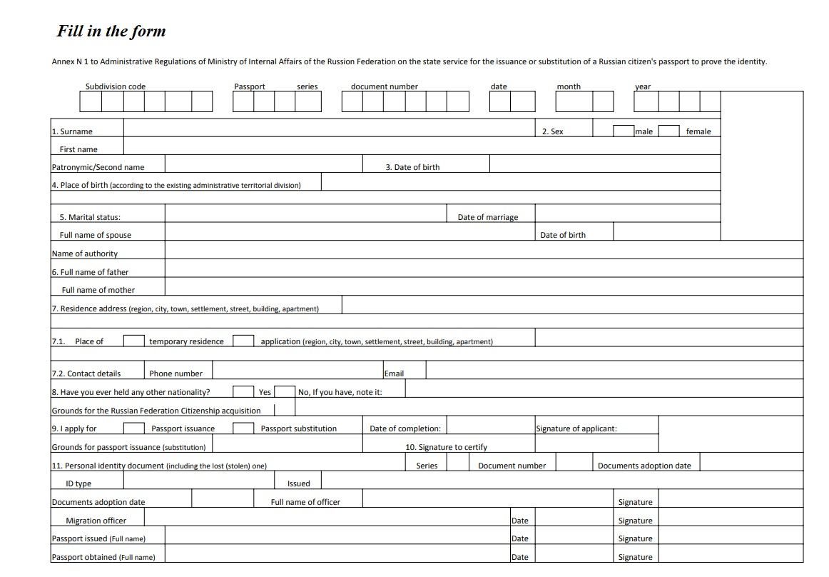

№ 5. Writing. Дополните письмо вашему англоговорящему другу Нику необходмыми словами и знаками препинания. Адрес вашего друга: Россия, Москва, ул. Остоженка, д. 25, кв. 10.
__________________________
__________________________
__________________________

_ _ _ _ Nick,
Thank you for your _ _ _ _ _ _. It was great _ _ _ _ _ _ _ _ _ _ you!
In your letter you asked me _ _ _ _ _ the procedure of obtaining an identity card. Well, here in Russia we don’t have ID cards. We have _ _ _ _ _ _ _ _ _. This is the main _ _ _ _ _ _ _ _ which we use to _ _ _ _ _ _ _ our identity. Each person gets a _ _ _ _ _ _ _ _ at the age of _ _. It’s very _ _ _ _ to do it. You just have to come to a Multifunctional Centre of Public and Municipal Services with a photo of yours and fill in a special _ _ _ _.
I got mine last year. Now I’m looking forward to getting a driving licence! Ha- ha!
That’s all for now. My favorite TV programme starts.
_ _ _ _ _ _ _ _ _ _ _ _ _!
_ _ _ _ _ _ _ _ _ _
_ _ _ _ _ _ _ _ _ _ _ _ _ _

- Голографическая инсталляция «Современная Россия».

№ 6. Watch the installation and mark the statements as ‘True’, ‘False’ or ‘Not stated’.

- The Multifunctional Centers for Provision of State and Municipal Services have been with us for several decades. _____
- The interaction has become less stressful. _____
- Multifunctional Center for Provision of State and Municipal Services is the center of attraction for citizens living anywhere in the world. _____
- People come to the centre to solve political problems. _____
- Comfortable conditions are created for visitors who come to receive public services. _____

- Зона артефактов «До 1722», «1722–1917» и «После 1917».

№ 7. Match the words with their definitions.

1 | 2 | 3 | 4 | 5 | 6 | 7 | 8 | 9 | 10

1. Parchment.
2. Ink.
3. A quill.
4. A passport.
5. A paper knife.
6. A typewriter.
7. A certificate.
8. An abacus (pl. abaci or abacuses).
9. A presse papier.
10. An oath of allegiance.

- A machine with keys for producing alphabetical characters, numerals, and typographical symbols one at a time on paper inserted round a roller.
- An official document issued by a government, certifying the holder's identity and citizenship and entitling them to travel under its protection to and from foreign countries.
- An oath given by one party in a lawsuit at the request of the other party, affirming the truth of a fact which the first party relies upon but cannot prove (and which the second party cannot disprove), and which is treated as proving the fact in question; also called decisive oath, proof by oath.
- A coloured fluid or paste used for writing, drawing, printing, or duplicating.
- A simple device for calculating, consisting of a frame with rows of wires or grooves along which beads are slid.
- A stiff, flat, thin material made from the prepared skin of an animal, usually a sheep or goat, and used as a durable writing surface in ancient and medieval times.
- A tool used for opening envelopes, typically one shaped like a knife.
- A written grant by the sovereign or legislative power of a country, by which a body such as a city, company, or university is founded or its rights and privileges defined.
- The pointed end part of a pen, which distributes the ink on the writing surface.
- A small, heavy object for keeping loose papers in place.

№ 8. Find the answers to the following questions:

- Зона артефактов «До 1722».

When was the first version of the Table of Ranks issued?

_____________________________________________________________________________

- Зона артефактов «1722–1917».

Who was the oath of allegiance, presented on display, written to?

_____________________________________________________________________________

What was mostly put on personal stamps?

_____________________________________________________________________________

- Зона артефактов «После 1917».

What kind of reward was given to shock workers in the Soviet Union?

_____________________________________________________________________________

What is the name of the most popular typing device?

_____________________________________________________________________________

- Конференц-зал.

№ 9. Watch the film and answer the questions.

- What was the registration required for in the 17th century?
- legal relations, wills, grants of land or property;
- travelling abroad;
- employment.

- What did peasants need to leave for another province?
a) a birth certificate;
b) a roadway letter;
c) a passport.

- Which inventions improved the methods of document production in the 19th century?
a) printing and copy machines;
b) the Internet and wi-fi;
c) databases.

4. What saves time on paperwork?
a) a queue management system;
b) a database;
c) necessary information.

5. What can be paid automatically?
a) the personal fee;
b) the ticket on a ship;
c) the state fee.

